ULVERSTON TOWN COUNCIL
GRANT APPLICATION FORM
2024-25
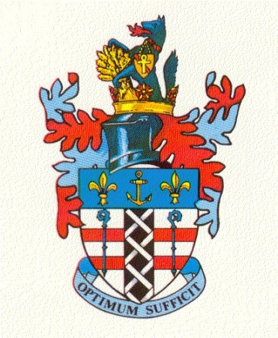

Ulverston Town Council welcomes grant application from local groups, charities and festivals throughout the year. All groups who apply must have a committee, constitution and bank account. Other applications may be considered only in exceptional circumstances.

Application deadline 22nd March 2024

Application Form
YOUR ORGANISATION DETAILS (PLEASE PRINT CLEARLY):

Name of Organisation: ……………………………………………………………………………….

Address: ……………………………………………………………………………………………….
…………………………………………………………………………………………………………..
…………………………………………………………………………………………………………..

YOUR DETAILS:
Name: ……………………………..…………………………………………………
Position in Organisation: ……………………………………………………………………………….
Address for correspondence (if different from above): ………………………..……………………..…………………………………………………………….

Postcode: …………………………………………………………………………………………………..
Tel: ………………………………………………...…………………………………………………………
Mobile:………………………………………………………………………………………………………l: Email:……………………………………………………………………………………………………….

YOUR PROJECT:

Provide a brief description of the project, event, festival or scheme for which the grant is intended.
Please use a separate piece of paper if required.

b) Total cost of your project or scheme: £…………........

c) How much are you applying for from UTC: £……………….

d) How much of your own funds are your contributing: £………………..

d) Which other organisations have you applied to and what was the outcome?

Use of the Town Council Crest
If your grant application is successful, a copy of the Town Council Crest will be supplied electronically. It can be used on social media, posters, event flyers etc. to acknowledge the grant. If the Town Crest is associated with any negative posts on social media or elsewhere, the Town Council reserve the right to withdraw the use of the crest at any time.

INFORMATION REQUIRED FROM YOU/ YOUR ORGANISATION:
All applications must be accompanied by the following information. If you do not supply this information your application will not be considered.

- A copy of your latest approved statement of income and expenditure or other financial report which indicates your financial position, or
- Photocopy of bank statements covering the past month
- A statement of your capital assets, if any
- Copy of your constitution
- How your organisation is going acknowledge the Council’s grant

I/we agree that:

- The information we have provide in this application is correct
- We will complete and return a Grant Evaluation Form when requested

Signed: …………………………………………………………………………...

Print Name: ………………………………………………………………………

Date: ……………………………………………………………………………….

Bank Account Name: ……………………………………………………………

Sort Code: …………………………………………………………………………

Account Number: …………………………………………………………………

This information will NOT be stored by Ulverston Town Council. The Town Council is registered under The General Data Protection Regulation (GDPR) 2018.

Please return together with all documents to:

The Town Clerk, Ulverston Town Council, County Square, Ulverston, Cumbria. LA12 7LZ
All applications will be considered by the Council’s Finance and Grants Committee and their recommendations will be discussed at a full Ulverston Town Council meeting.

If you have any queries, please contact the
Town Clerk on 01229 585778 or email admin@ulverstoncouncil.org.uk

Town Council Office opening times:
Monday to Thursday 9am – 2pm, and Friday 9am - 12pm

