FINAL REPORT BY THE INTERNAL AUDITOR TO ULVERSTON TOWN COUNCIL
1ST OCTOBER 2024 – 31ST MARCH 2025
FINANCIAL YEAR ENDING 31ST MARCH 2025

Introduction
This final report for the financial year 1st April 2024 to 31st March 2025 covers elements required by the Account and Audit Regulations (England) 2015 which were not covered
in the interim report for the period 1st April 2024 – 30th September2024.

I confirm I have on the 21st May 2025 undertaken a final audit which covers the period 1st October 2024 to 31st March 2025 in accordance with the Account and Audit Regulations (England) 2015 as outlined in the schedule previously circulated and approved by Council and incorporating any new requirements as outlined in “Governance and Accountability for Smaller Authorities in England” March 2024

Appropriate accounting records have been kept throughout the year.
The completed 2025 Annual Governance and Accountability Return (AGAR) confirms that the closing balance of 31st March 2024 has been correctly carried forward to 1st April 2024 to commence the financial year to 31st March 2025

The authority complied with its financial regulations, invoices supported payments, all expenditure was approved, and VAT was accounted for.
The rigorous tendering process for goods and services was evidenced by the documentation
made available. All tenders and quotes adhere to the up-to-date Financial Regulations.
A selection of financial transactions was reviewed particularly those in excess of £3000.00, all were supported by a clear audit trail.
Vat reclaims are prepared on a quarterly basis. Evidence was available to confirm the reclaims for January, February and March. – Xero reconciliation and HMRC verification.
The claim for the final month of the financial year 31st March 2025 had been reconciled and submitted to HMRC -£5946.24

The authority assessed the significant risks to achieving its objectives and reviewed the adequacy of arrangements to manage these.
The review of the Risk Assessment documentation is undertaken annually. There is on-going monitoring of risks though out the year and the risk policy documents are amended if appropriate. All Risk Assessments and Health and Safety Policy documents were received at the meeting – 17th March 2025 – Minute No. B172, reviewed and adopted.

The Precept requirement resulted from an adequate budgetary process, progress against the budget was regularly monitored and reserves are appropriate.
The Responsible Financial Officer (RFO) with full explanations of the recommendations, prepares a budget report and it is presented to the Finance Committee for approval and development prior to recommendations being made to Council. The Council subsequently approves the budget and the precept to be requested for the 2025-2026 financial year. -
Meeting – 20th January 2025 – Minute No. – B134d. - £290,045.
The budget is set in time to comply with Westmorland and Furness Council’s timetable.
The balances at the bank as at the 31st March 2025 - £394,263 are considered adequate to enable the Council to fulfil budgeted expenditure, deliver planned projects and retain an adequate cash flow. Within the cash balances are clearly defined ringmarked amounts and earmarked reserves totalling £154,471.91.
External Audit guidance advises free revenue cash reserve nearer 3 months Net Revenue Expenditure (N.R.E.) for authorities with a N.R.E. in excess of £200,000.

Expected income was fully received based on correct prices, properly recorded and promptly banked and VAT appropriately accounted for.
The Council has minimal income from sources other than the Precept. Where received, it is properly recorded and promptly banked. Controls are in place to ensure the collection of cash is segregated from the reconciliation and subsequent banking.

Receipts properly supported Petty Cash payments, all petty cash expenditure was approved and VAT appropriately accounted for.
The Council does not operate a Petty Cash account. Expenditure incurred on the Debit Card is supported by invoices/receipts and presented for reimbursement. VAT is identified and purchases are allocated to the appropriate budget headings.

Salaries to employees and allowances to members were paid in accordance with the authority’s approvals and PAYE and NI requirements were properly applied
All payments reflect salary scales approved by Council. Returns to HMRC are
processed by the external accountant. The record with all deductions for staff was properly prepared and available for inspection.

Assets and investments register were completed and accurate and properly maintained.
The Asset Register for the current financial year has been completed, reviewed and adopted, as it is annually, to a scheduled timetable ensuring accuracy for completion of the 2024- 2025 AGAR. – Assets total, which records acquisitions and disposals - £3,575,014.
All assets are adequately covered by insurance – renewal 14th January 2025 – 13th January 2026.

Accounting statements prepared during the year were prepared on the correct accounting
basis – income and expenditure, all schedules, etc agreed and were supported by an
adequate audit trail from the core Xero accounts. Debtors and Creditors were properly recorded. The Council has published on the website all documentation required under relevant legislation.
The Council accounts are prepared on an Income and Expenditure basis as required by the Accounts and Audit regulations, being an authority with income/ expenditure in excess of
£200,000. The Xero software clearly identifies Debtors, Creditors, Receipts in Advance, and Accruals.
Notification of the receipt of the External Auditors completed AGAR and the resolution of minor matters was reported to Council – meeting 17th February 2025 – Minute No. B152.
It is confirmed that the Council is fully compliant with requirements to publish information in line with relevant legislation.

The audit reports confirm that Ulverston Town Council has fulfilled its statutory obligations, and all finance and procedures comply with legislation. The comprehensive website ensures the electorate is fully aware of the use of all public funds.

I wish to express my appreciation to the Town Clerk/Responsible Financial Officer and Officers of the Council for the preparation of all relevant financial reports, comprehensive governance documents and the completeness of information on the website which facilitated the audit.

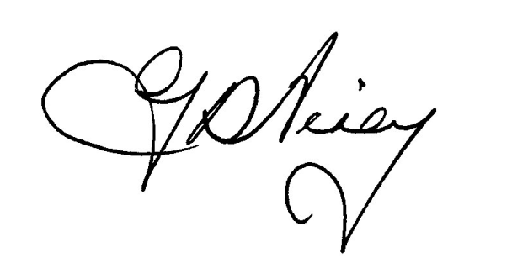
Georgina D Airey - Internal Auditor – 21st May 2025.

