Ulverston Town Council
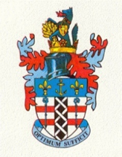
Annual Town Meeting
Monday 11 May 2026
The Coronation Hall, Ulverston. 7pm (Main Hall)

Agenda
- Welcome from the Town Mayor

- Introduction and summary of the Annual Report:
Town Clerk

- Mayors’ summary of the year

- Standing Committees. An update from the Chair of
- Finance and General Purposes Committee and Leader of the Council
- Environmental Sustainability Committee
- Allotments Committee
- HR Committee

- Guest Speaker. Ceri Hutton from The Spot

- Presentation by the Mayor of grant awards from the Mayors Fundraising 2025-26
- Every Life Matters
- North West Air Ambulance

- Questions from the community

- Close

Free refreshments will be served following the meeting, all very welcome to stay

